Practical: 6

1. Install wamp & learn localhost and php myadmin.

Installation of wmp

Step 1:

I have downloaded the wamp server which is there in the zip format. Extract the contents and execute the setup.exe. Following window may appear on the screen..

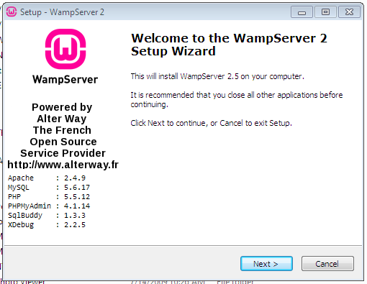

Step 2: Click Next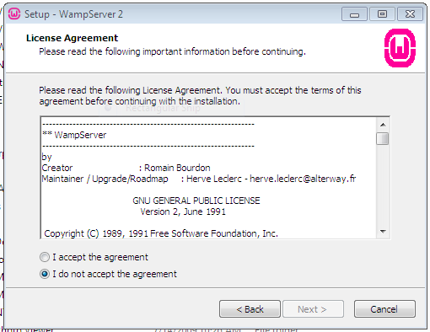

Step 3:

Just click to next button to proceed.

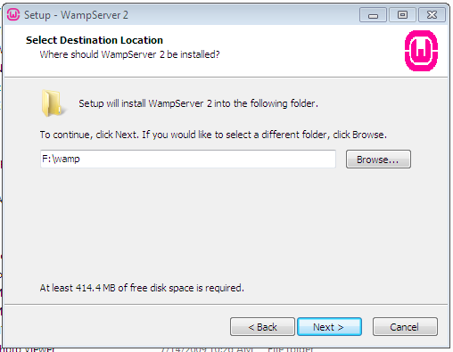

Step 4:

Then click next button and following window appear which check the check box.

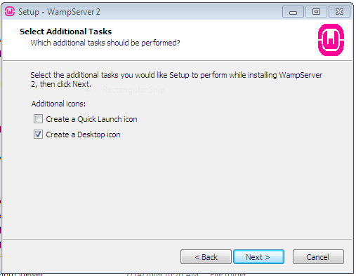

Step 5:

Set the installation path. And click install button.

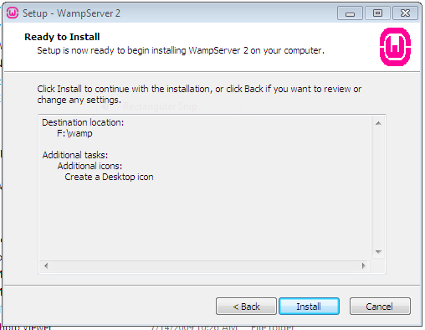

Step 6:

Installation is running.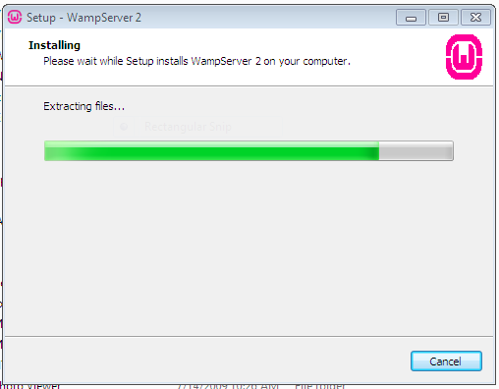

Step 7:

Click finish.

